Sequence Diagram: Result Entry & Critical Alert
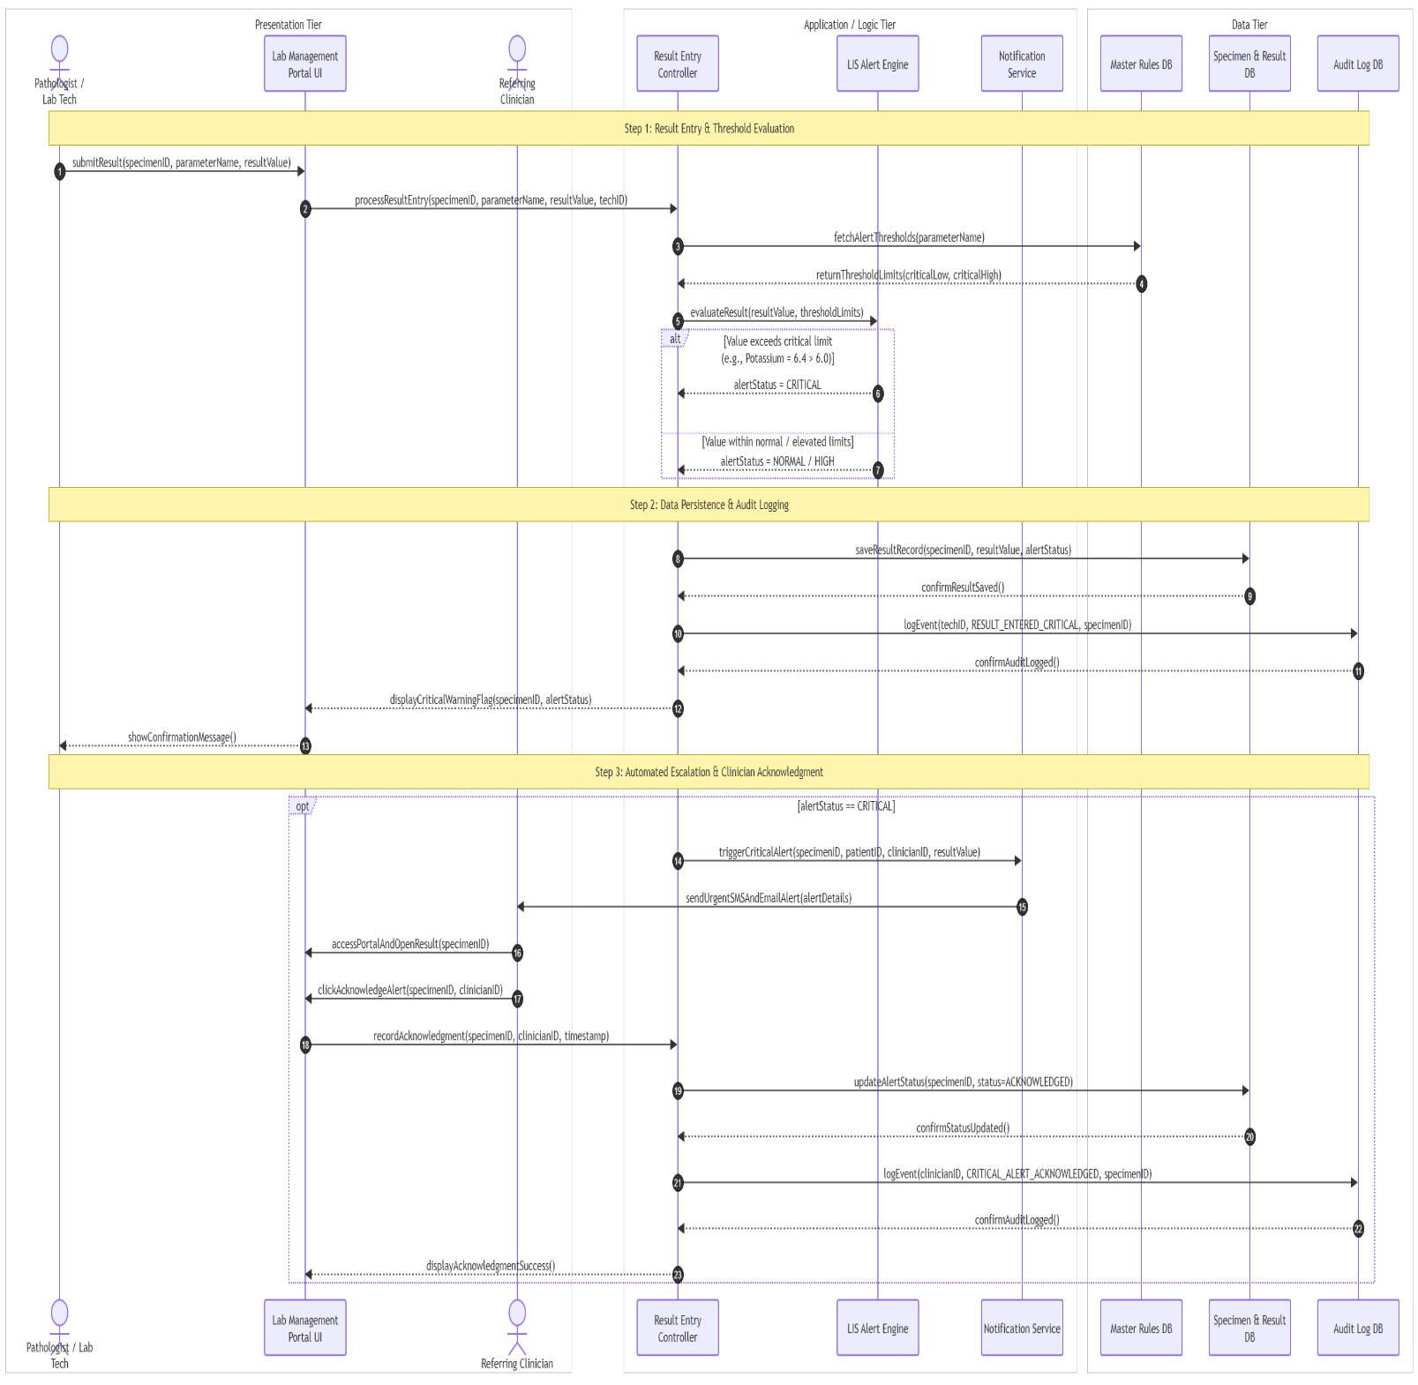

FR MAPPING TABLE

Sequence Step | Objects Involved | Mapped FR No.
Step 1: Message 1–2 | Lab Tech -->Lab Management Portal UI --> Result Entry Controller | FR27
Step 1: Message 3-5 | Result Entry Controller $↔$ Master Rules DB | FR29
Step 1: Message 6-7 | Result Entry Controller | FR30
Step 2: Message 8–9 | Result Entry Controller -->Specimen & Result DB | FR33, FR35
Step 2: Message 10–11 | Result Entry Controller --> Audit Log DB | FR44
Step 2: Messages 12–13 | Result Entry Controller -->Lab Management Portal UI -->Lab Tech | FR27, FR30
Step 3: Message 14–15 | Result Entry Controller -->Notification Service -->Referring Clinician | FR31, FR43
Step 3: Message 16–20 | Referring Clinician -->Portal UI -->Result Entry Controller -->Specimen & Result DB | FR32
Step 3: Message 21–23 | Result Entry Controller -->Audit Log DB -->Portal UI | FR44

